IMAT2207 Agile Team Development
Practical – Unit 6
Building Your Allocated Component
Adding a Simple Presentation Layer

Adding a Basic Presentation Layer 1
Before you Begin 1
Start Your Git Hub Day 1
Adding Code 6
Tidying up the Interface 9
Linking the Middle Layer 11
Using the Class to pass data to another page 13
What you need to do 15
End Your GitHub day 15

Adding a Basic Presentation Layer

Before you Begin
Make sure that you have completed the work for last week and that you have watched the eLectures for this week before starting this work.
In order to prove that this is working let’s add a simple web interface to capture some data from the user on one form and pass it to a second form.

Start Your Git Hub Day
As always make a fresh clone of the master and create a new branch to work in.
When the skeleton was set up you will have been allocated four web forms within the AdminSystem web site. In my case these are…
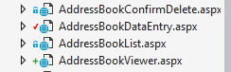
Double click on your allocated DataEntry form and you will see the HTML displayed likes so…
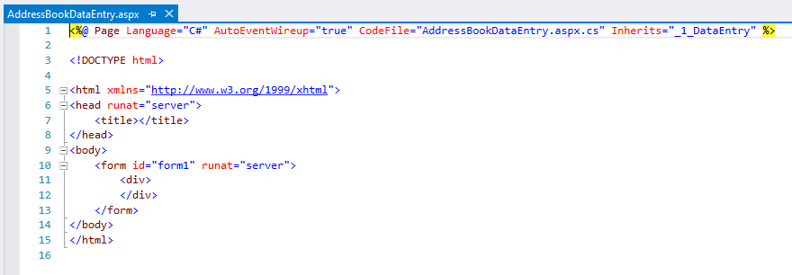
If you enjoy pain, you are most welcome to edit the HTML directly but one advantage of using web forms is that there is an option of a handy drag and drop designer.
At the bottom of the window containing the HTML you should see a button labelled “design”…
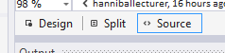

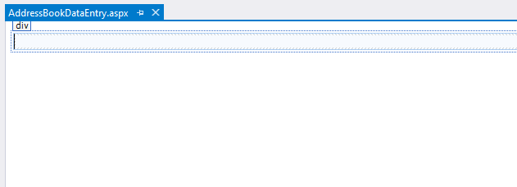
Press this and you will change views to the drag and drop editor…

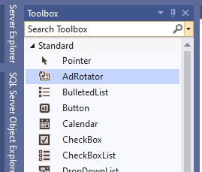
Typically, on the left of the Visual Studio interface you should see the toolbox.
If it isn’t there go to ‘View’ on the main menu and select ‘Toolbox’ from the list of options.
Make sure you have the ‘Standard’ tools open like so…

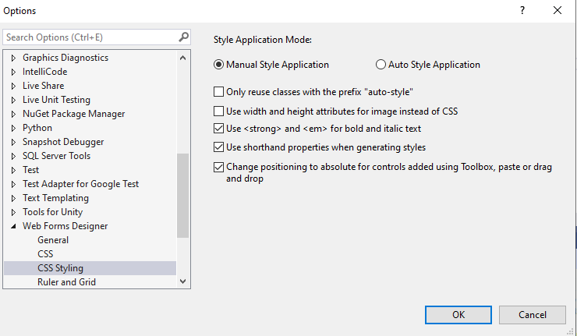

Next go to Tools on the main menu and select ‘Options…’
Navigate to ‘Web Forms Designer’ and then ‘CSS Styling’.
Make sure the box for ‘Change positioning to absolute for controls added using Toolbox, paste or drag and drop’ is checked.

Let’s start by setting up a label control.
From the toolbox drag and drop the following control to the white background of the web form…
Once done it should look something like this:
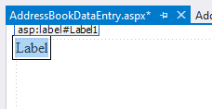
In the bottom right hand corner of the interface you should see a section marked properties like so…
(If the properties window isn’t present, right click the label and select ‘Properties’ from the list)
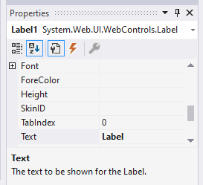
Click the A-Z button to sort them alphabetically, it makes things easier to find.
Locate the property for ID and set it up for the primary key of your table, in my case lblAddressNo
Make sure you get the capitalisation right as it makes it easier to read…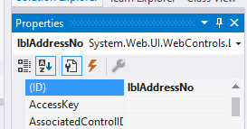

Next locate the property for text and set this with the text the user will see…
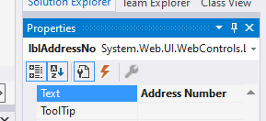
Your web form should look something like this…
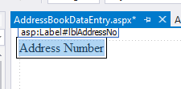
Next set up a text box from the toolbox…
Set the ID to txtAddressNo and leave the text blank. Note the ‘txt’ prefix…
The web form should now look like this…
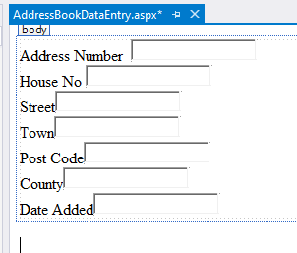
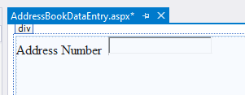

Set up the rest of the properties for the record as controls on the form so that it looks something like this…

Next create a check box for the Boolean attribute in your table, in my case “Active”…
Set the properties like so…
ID chkActive
Text Active

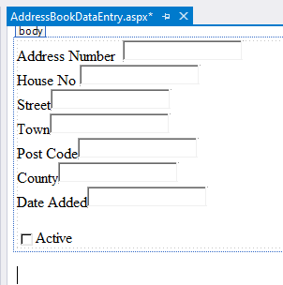
The page should now look like this…

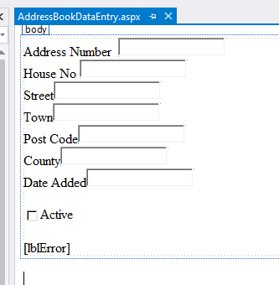
Next add a new label control for error messages called lblError, set the text to blank…

Lastly create two buttons…
Like so…
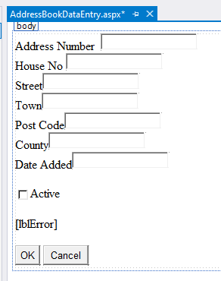
The ‘OK’ button has the following properties:
ID btnOK
Text OK

And the ‘Cancel’ has these:
ID btnCancel
Text Cancel

Adding Code
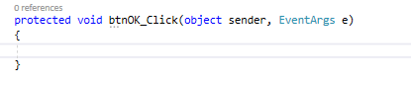
Double click on the OK button and it should take you to the function that handles the click event from the user….

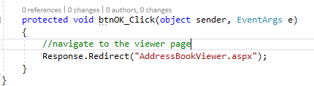
Modify the function so that it navigates to the viewer page for your part of the system. Make sure add comments. The code should look like this:

Now we’re going to test the navigation of the pages.
Right click on the AdminSystem web site in the Solution Explorer and make sure it is the start-up project for the solution…
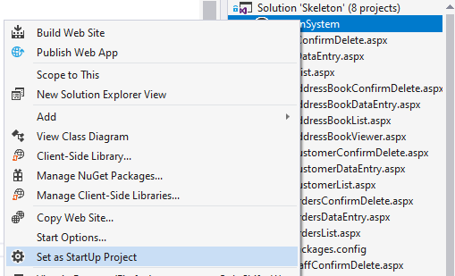

Next right-click on your data entry page to make it the start-up page…
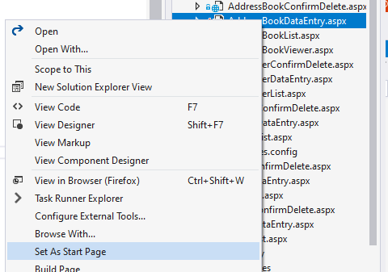
Now press F5 (or the green play button on the main menu) to run the program. If everything works OK you should see the data entry page displayed in the browser…
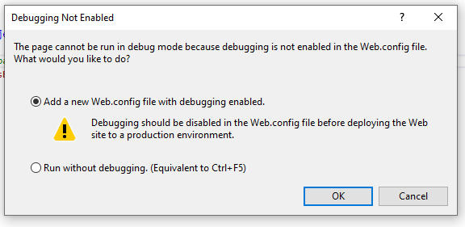
If you see the following message just press OK

The browser should display the following…
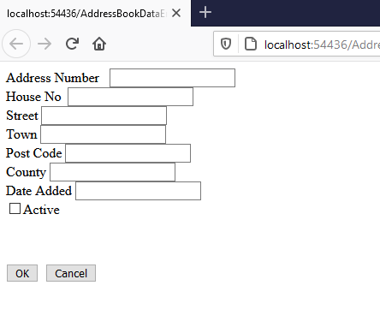

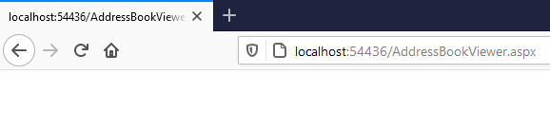
Press the OK button and the browser should navigate to the viewer page. Note there is no content for this page yet.
Stop the browser (use the stop button on the main menu or close the tab in the browser) and get back into editing mode.

Tidying up the Interface
The interface is looking a bit messy so let’s tidy it up a bit by extending the size of the label controls.
Click on the longest label once to select it…
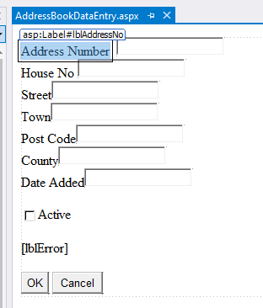
Hold down the control key and while keeping it pressed and click once on each label…
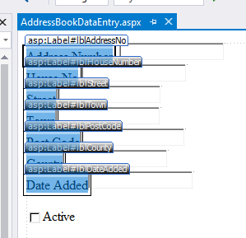
When all the labels have been selected, from the main menu select ‘Format’ then ‘Make Same Size’ and then ‘Width’…
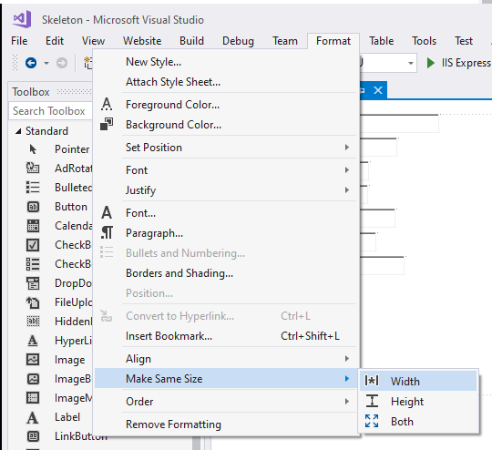
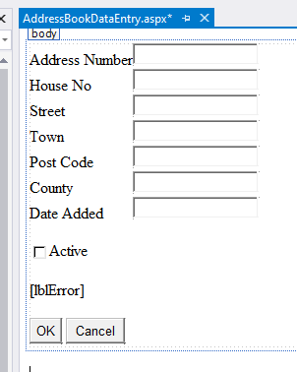
This should make things look a bit more aligned…

Linking the Middle Layer
We now want to tell this page in the presentation layer where our code is stored in the Class Library.
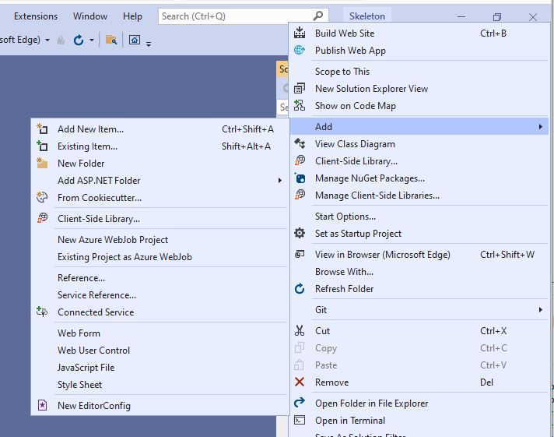
Right click on the web site and select ‘Add’ and then ‘Reference’…

You should see the following page…
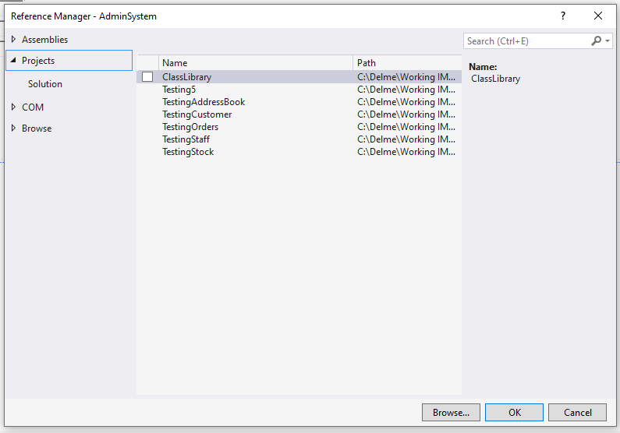
Under Projects and then Solution you should see your Class Library listed, make sure there is a tick beside it and press OK.
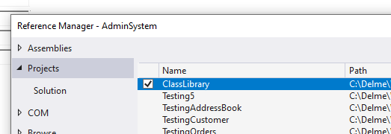

Next sure there is a ‘using’ that tells the page to use your class library…
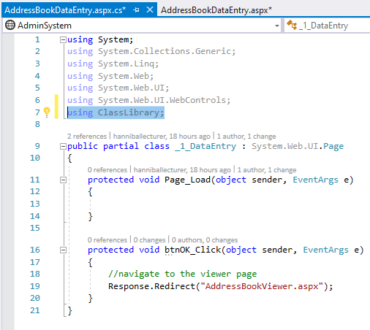
You are now able to use the class you created in the Class Library within your code.

Using the Class to pass data to another page
What we want to do next is create an instance of the class clsAddress and store some of the data in the object to display on a second page.
To do this we need to modify the OK buttons event handler from this…
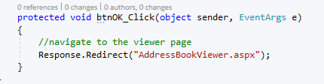
To this…note the comments
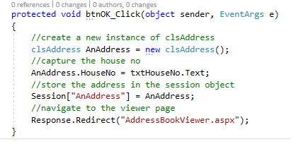
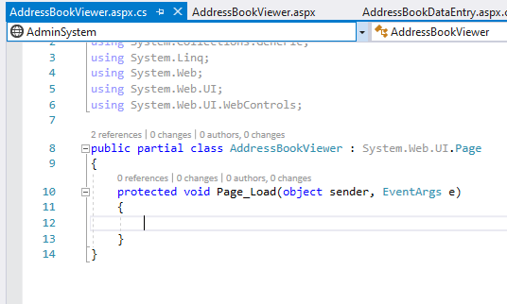
We now need to modify the viewer page such that it uses this data to display something.

Open AddressViewer.aspx in Design View and double click the page to access the event handler for page load…

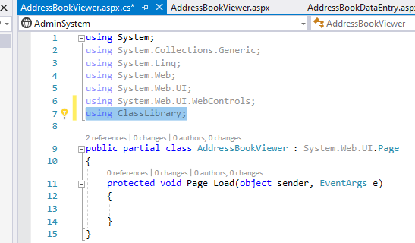

Add a ‘using’ to the top of the page so that it knows about your class library…

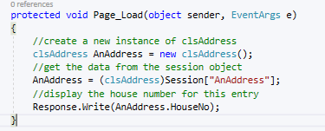

Now modify the load event like so…

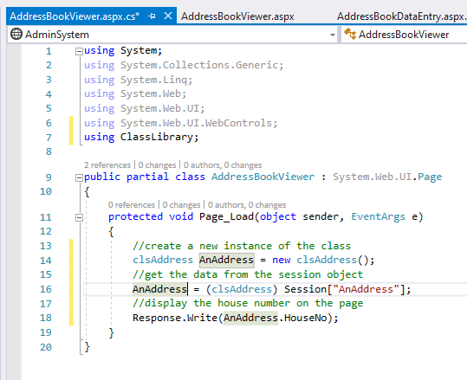

The code should now look like this…

Run the program and you should see the address data entry page displayed...
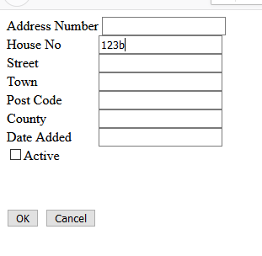
Enter some data as above.
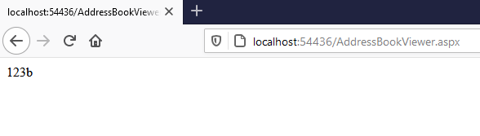
Press OK and the viewer page should be displayed but this time it should display the house number you input on the first page…

What you need to do
At this point you now need to modify the above code so that you are able to input values for all of the attributes of your own class.
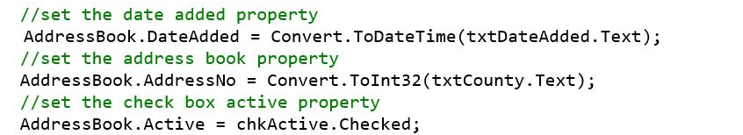
For data types other than strings or different controls you will need to convert the values from the text boxes like so:

Do note that as yet the data is not validated so entering bad data will crash the program.

End Your GitHub day
Once everything is working perfectly merge the work to the master and delete the unwanted branch.

